Process for Completing Investigations Involving Facilities in TWIST

In the past, there has been much discussion related to entering referrals and investigations in TWIST, which involve facilities or hospitals. TWIST does have the capability and functionality to link individuals to facilities or hospitals. For the purpose of continuity, facilities and/or hospitals will be referred to as “Resources” in this document.

When a referral is entered in TWIST, on the Referral Individuals tab and in the Referral Individuals table window there is a field titled “Resource Name”. This field is where the name of the Resource involved will be displayed. On the first row of the Referral Individuals table window, which is displayed below, “John Stewart Smith”, is listed as a referral individual. In this scenario, he is employed by the “Butterflies Are Free Day Care Center” and has allegedly physically abused “Elizabeth Child”. To link “John” to the “Butterflies Are Free Day Care Center” the worker would double click in the “Resource Name” field to search for the Resource in the Resource Directory.

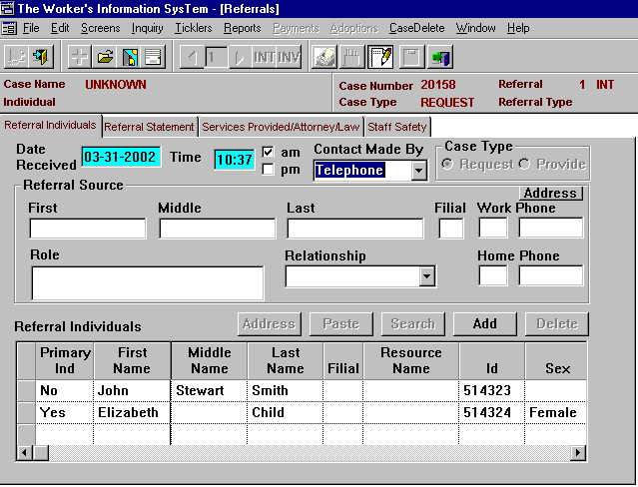
Resource Name Field. Double Click to search for the Resource where the individual listed in the table window is employed.
After double clicking in the “Resource Name” field, a Resource Search screen will display. Staff will have the ability to search for the resource based on the Resource Type, the county where the resource is located or the name of the resource while keeping in mind that the more narrow the search criteria, the fewer results will be displayed. There is also functionality that provides the worker with the ability to search using “Begins With” and “Sounds Like”. It should be noted that searching for resources from the Resource Directory provides for more accurate and consistent data with less duplication.

Below is the Resource Search Results screen. In the table window the “Butterflies Are Free Day Care Center” is listed. By highlighting the row in the table window and clicking “OK”, the resource will be linked to “John Stewart Smith”, the alleged perpetrator and will be displayed in the Referral Individuals table window in the Referral screens.

Search Results listing the Resource where the Alleged Perpetrator is employed.
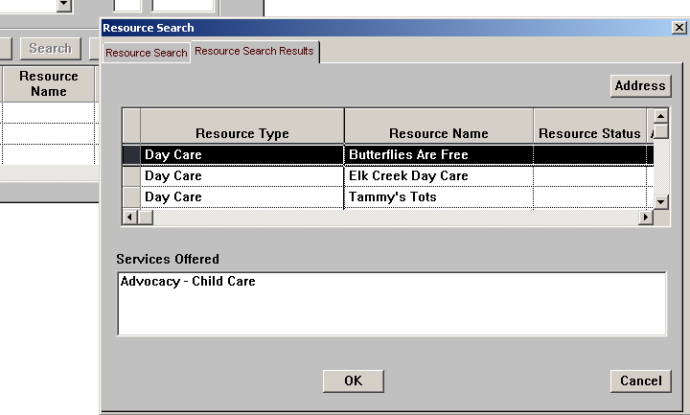

When the Resource populates the “Resource Name” field in the Referral Individuals table window, a message will then display for the worker. The message indicates “By entering both an individual name and a resource name, you are indicating that the individual’s involvement in the referral is in his /her capacity as an agent / employee of the resource.” The message will no longer display after the worker clicks on “OK”

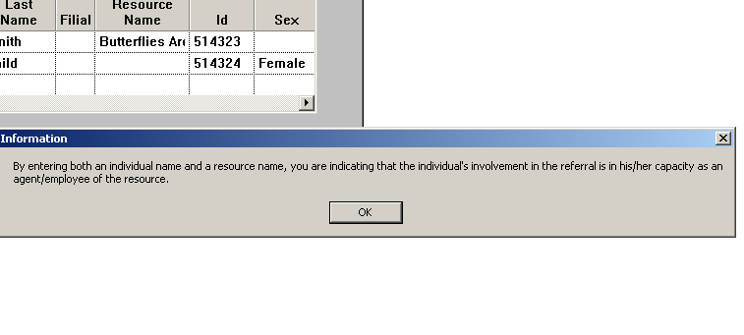

INCIDENT DETAILS SCREEN - ROLE AND RELATIONSHIP FIELDS

Please note… When entering an investigation in TWIST involving a facility, hospital or resource it is essential that the Roles and Relationships of the Alleged Victim and Alleged Perpetrator be accurately selected. In the Incident Information screen, an individual may have multiple Roles in an Incident. For example if the Alleged Perpetrator of child abuse is an employee of a PCC Residential facility, it is imperative that the Roles reflect both. TWIST allows for multiple selections for Role. The relationship of “Non-Relative” should be selected.

If the Alleged Perpetrator is an employee of a Day Care Center, the Roles selected should be “Alleged Perpetrator-Caretaker” and “Child Care Personnel. The Relationship should be “Non-Relative”. The Resource Type would be “Day Care”.

If the Alleged Perpetrator of Child Abuse or Neglect is an operator of an approved PCC Foster Home, the Roles selected should be “Alleged Perpetrator-Caretaker” and “Foster Parent”. The Relationship selected should reflect the “Foster Parent” relationship, for example “Foster Father, Foster Mother, etc. The Resource Type would be “Private Child Care”.

If the Alleged Perpetrator of Child Abuse or Neglect is an employee of a School, the Roles selected should be “Alleged Perpetrator-Caretaker” and either “School Counselor”, “School Nurse”, “School Personnel”, or “Teacher”. The Relationship should be “Non-Relative”. The Resource Type would be “School”.

One other issue related to entering referrals and investigations involving a facility or a resource in TWIST is the ability to query the TWIST database to view historical information related to that facility or resource. By accessing the “Victim / Perpetrator Search” inquiry screen, workers have the ability to see a complete history of substantiated abuse and / or neglect allegations involving that resource.

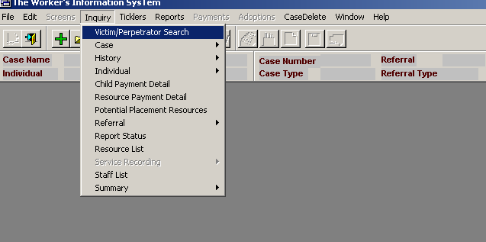

Access to the Victim / Perpetrator Search Inquiry Screens may be accomplished with a case open or not. When the screens display, the worker has the ability to search for an individual or for a resource by selecting either the “Individual radio button” or the “Resource radio button”.

Select from what “Data Source” you want the search to execute…

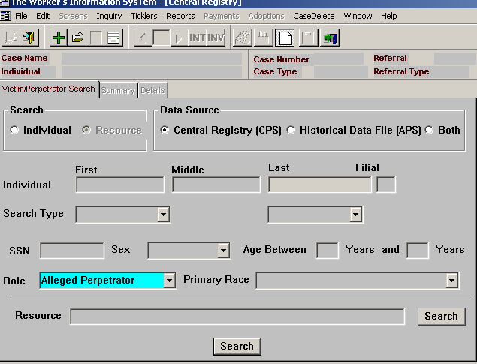
Search Type (Individual radio button or Resource radio button)
To search for a previously substantiated abuse / neglect report for a resource, click on the “Search” button to first search for the name of the Resource in question.
After clicking on the “Search button” the Resource Search Screen will display. From there, the user selects the “Resource Type” from a drop down list and may also enter the name of the resource (if the correct spelling is known) and then clicks on the “Search button”. Keep in mind that the more narrow the search criteria, the more narrow the search results.

After selecting the Resource Type and searching, the “Resource Search Results” screen will display the resource for which the worker is searching. To conduct a search for previous substantiated allegations of abuse or neglect involving that resource, the worker must make a selection and then click “OK”. The resource name will then display in the “Resource field” on the Victim / Perpetrator Search Inquiry screen.

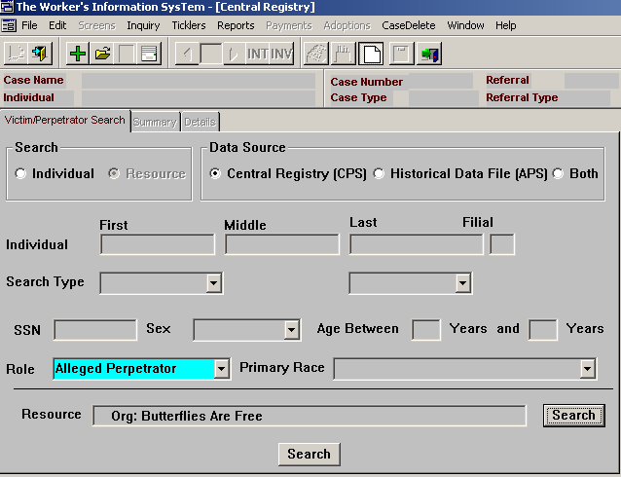

Below are the results of the search for previous substantiated investigations involving the “Butterflies Are Free Day Care Center”. The table below the screen print lists information displayed in the search results “Summary tab”. The worker may scroll to the left and right. By highlighting a row ant then clicking on the “Details button”, details about each referral will display on the “Details tab”.
Name | Resource | Data Source | Date of Birth | Age | Sex | Primary Race | SSN | DSS Number | DSS Name | Address | Case Manager | District
Smith, John Stewart | Butterflies Are Free | Central Registry (CPS) | 01-18-1962 | 40 | Male | White | 456-94-31 | 20158 | John Stewart Smith | 1 | King, Sue | Fayette

Note: All substantiated referrals linked to the resource are displayed in the “Summary tab” table window.

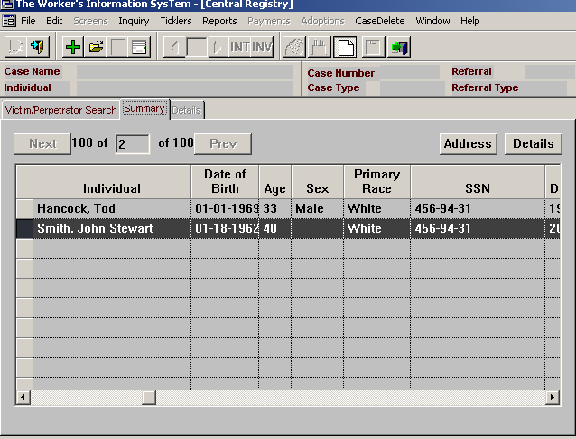
Details Button

Data displayed from the Victim / Perpetrator Search Inquiry screen Summary tab.

Victim / Perpetrator Search Details Tab

The Victim / Perpetrator Search Details tab displays specific information related to each referral listed in the “Summary tab”. The information includes who was identified as the alleged perpetrator, the program /subprogram, who was identified as the alleged victim and the results of the investigation. In addition, the alleged perpetrator’s SSN, Sex, Primary Race, Date of Birth, Age and relationship to the alleged victim is displayed. Information identifying the alleged victim’s Sex, SSN, Primary Race, Date of Birth and Age is also displayed.



